**Allowing All IP Ranges**

**Objective:**

To create a Kubernetes service with a load balancer that allows traffic from all IP ranges.

**Prerequisites:**

Access to a Kubernetes cluster.

Basic understanding of Kubernetes concepts like Pods, Services, and YAML configuration files.

**Steps:**

Create a Kubernetes Service YAML file:

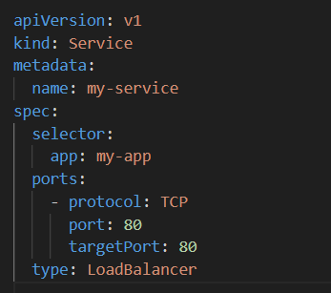

1. Save this yml file with name service.yml
2. Once you apply using 🡺 **kubectl apply -f service.yml**
3. To verify 🡺 **kubectl get svc**





1. It will create Security group with inboud rule to allowed all traffic 0.0.0.0/0 at port no 80

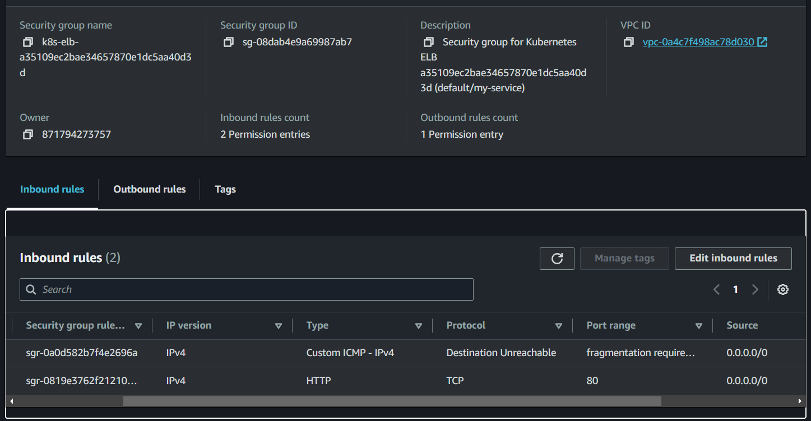



**Restricting Access to a Specific IP Range**

**Objective:**

To create a Kubernetes service with a load balancer that restricts traffic to a specific IP range.

**Prerequisites:**

Access to a Kubernetes cluster.

Basic understanding of Kubernetes concepts like Pods, Services, and YAML configuration files.

**Steps:**

Create a Kubernetes Service YAML file with IP Whitelisting:

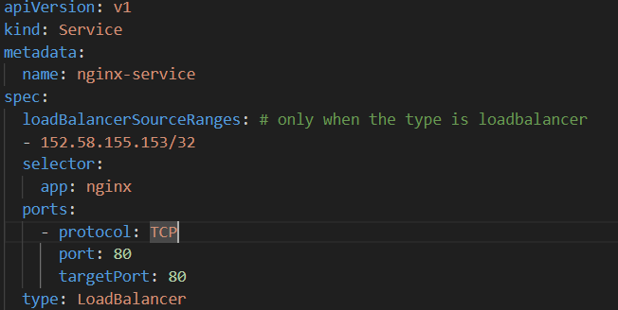

Apply the YAML file to create the Service:

1. Save this yml file with name service.yml
2. Once you apply using 🡺 **kubectl apply -f service.yml**
3. To verify 🡺 **kubectl get svc**





1. It will create Security group with inboud rule to allowed to specific IP Range at port no 80

